**Faculty of engineering - Shoubra**

**Benha University**

# Research Article/Research Project /Literature Review

in fulfillment of the requirements of

|  |  |
| --- | --- |
| **Department** | **Engineering Mathematics and Physics** |
| **Division** |  |
| **Academic Year** | **2019-2020 Preparatory** |
| **Course name** | **Computer** |
| **Course code** | **ECE001** |

## Title: - Operating Systems

By:

|  |  |  |  |
| --- | --- | --- | --- |
|  | Name | Edu mail | B.N |
| 1 | كريم سيف سعيد عباس | Karim195666@feng.bu.edu.eg | 599 |

**Approved by:**

|  |  |
| --- | --- |
| Examiners committee | Signature |
| Dr.Ahmed Bayoumi |  |
| Dr.Shady Elmashad |  |
| Dr. Abdelhamid Attaby |  |

**Application brief**

Why use an operating system?

An OS brings powerful benefits to computer software and software development. Without an OS, every application would wish to incorporate its own UI, also because the comprehensive code needed to handle all low-level functionality of the underlying computer, like disk storage, network interfaces then on. Considering the vast array of underlying hardware available, this is able to vastly bloat the dimensions of each application and make software development impractical.

Instead, many common tasks, like sending a network packet or displaying text on a typical output device, like a display, are often offloaded to system software that is an intermediary between the applications and therefore the hardware. The system software provides a uniform and repeatable way for applications to interact with the hardware without the applications wanting to know any details about the hardware.

As long as each application accesses an equivalent resources and services within the same way, that system software -- the OS -- can service almost any number of applications. This vastly reduces the quantity of your time and coding required to develop and debug an application, while ensuring that users can control, configure and manage the system hardware through a standard and well-understood interface.

Once installed, the OS relies on a huge library of device drivers to tailor OS services to the precise hardware environment. Thus, every application may make a standard call to a memory device, but the OS receives that decision and uses the corresponding driver to translate the decision into actions (commands) needed for the underlying hardware thereon specific computer. Today, the OS provides a comprehensive platform that identifies, configures and manages a variety of hardware, including processors; memory devices and memory management; chipsets; storage; networking; port communication, like Video Graphics Array (VGA), High-Definition Multimedia Interface (HDMI) and Universal Serial Bus (USB); and subsystem interfaces, like Peripheral Component Interconnect Express (PCIe).

صورة تحتوي على نص, خريطة

تم إنشاء الوصف تلقائياً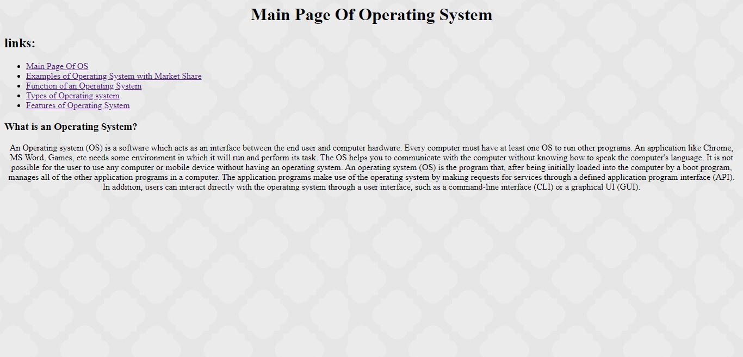**Screenshots**

صورة تحتوي على نص

تم إنشاء الوصف تلقائياً

صورة تحتوي على نص

تم إنشاء الوصف تلقائياً

صورة تحتوي على نص

تم إنشاء الوصف تلقائياً

**Source code**

صورة تحتوي على لقطة شاشة

تم إنشاء الوصف تلقائياً

صورة تحتوي على لقطة شاشة

تم إنشاء الوصف تلقائياً

صورة تحتوي على لقطة شاشة

تم إنشاء الوصف تلقائياً

صورة تحتوي على لقطة شاشة

تم إنشاء الوصف تلقائياً

صورة تحتوي على لقطة شاشة

تم إنشاء الوصف تلقائياً